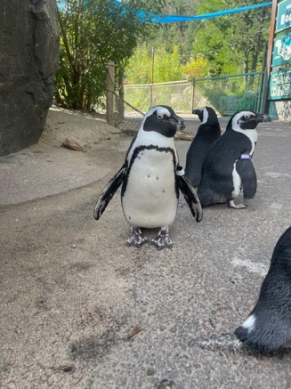 By: Jheffrey
I like the way you can tell what the penguin looks like, as in the design of the animals. You can tell where they are moving and overall, it is just a beautiful picture.
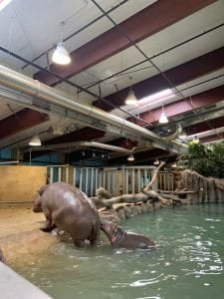 By: Joe
I really like how you can tell that the hippos are getting out of the water. You can tell the relation between the baby hippo and the mama hippo.
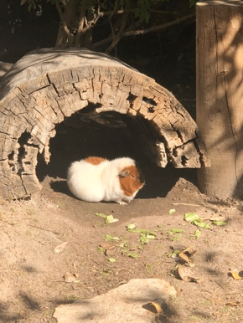 By: Josh
I like the way you got the guinea pig in the light with the shadow in the background. It is also cool how the wood looks because it looks hallow.
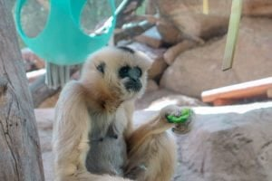 By: Kenzie
To me it looks like the monkey is eating his lunch like he is at school because that is also how the background looks. You did a great job on the photo.

