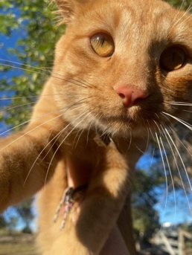 By Emma G
I love the way the light is shining down on the cat’s fur and makes it blurry, and the face is focused. I like the way you made the cat look like it was flying in the air, and it just looks cool.

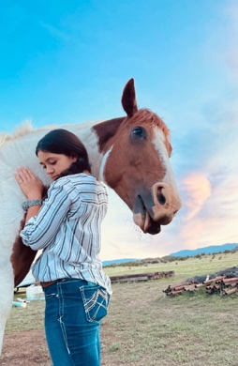 By Garret
I love the background in this photo. You made it look all put together and Hannah in the picture hugging the horse is adorable. I also really like how the horse is sticking his tongue out like he is trying to be funny or something.
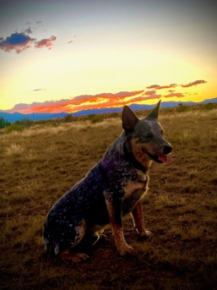 By Jheffrey
I love how you can see the mountains underneath the sunset, but the dog is the main part of this picture. You did a great job with this picture.

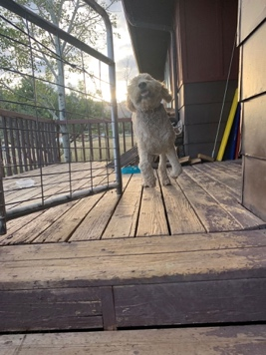 By Joe
I like the way you can see the dog’s movement. It is cool the way you can see where he is going without knowing where he is going.

