Comments 3
I love how there are two different colors the way the red shows and the yellow shoe. The two different colors make the picture unique. Great job
By Brendan Gray
I like how it doesn’t just show the leaves you got a beautiful background to your image, but it mainly focuses on the plant and the background is just there.
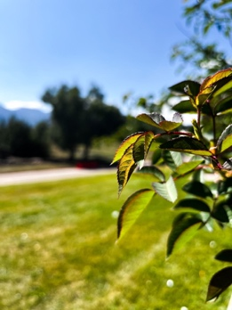 By Lacie Laca
I like how you got all the detailing on the bench it really pops out in your image, and it has a neutral color so nothing pops out except the details.
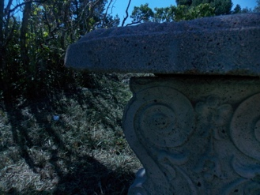 By Mackenzie Indgjer
I like the way that it looks like a flower in the image, but you know that it is a pine tree, and it looks like there is a flower growing on the end of it with the yellow spot that pops out to me.
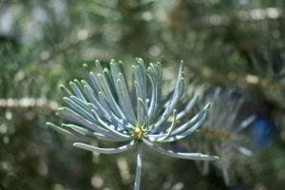 By Mazzy Miller

