Comments 2
Great picture. It all blends well together and I like the way it is all blue until you get to the electric line and the bottom of the picture it makes a beautiful image.
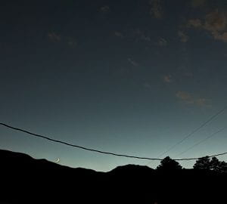 By Mylee Garner
I like how you can see the shadows on this picture of where the coin just moved from. You did such a good job on this picture.
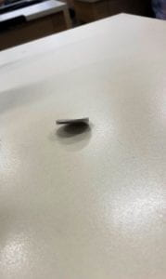 By Keyanna Kirk
I like how you can see all the different colors in this picture and it is not just focused on just one but it makes you look and it is beautiful.
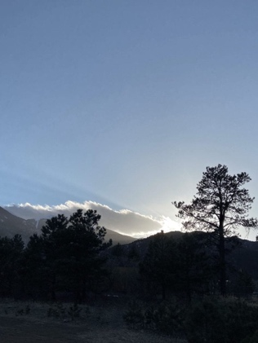 By Emma Garcia
I like how you can see all of the yellow flower and it doesn't focus much on the background good job on this image.
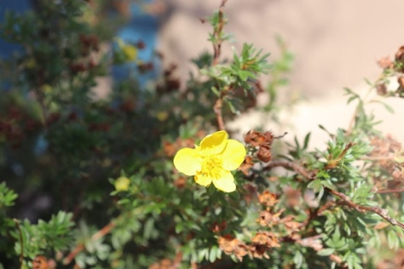 By Josh George

