Photo by: Keyanna Kirk
I love that you can see all the texture around it. The bottle is still there but I like how you can see what the background is even though it is blurry. The lighting is perfect, and I think you did a really nice job on this photo.
Photo by: Kenzie Nielson
Track: The shadow coming off the fence is what puts the image together. I love how you can see the lane of the track and the lighting is perfect.
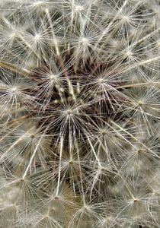
Photo by: Mackenzie Indjer
I love your picture. I like how you can see each different seed in this image. It looks so much like a ballroom and I love it. You did an amazing job on this photo.
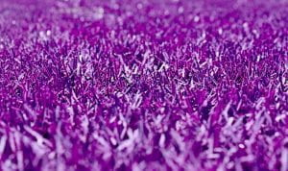
Photo by: Lily Jessop
I love how it focuses more on the middle of the image more than the edges. It is a really cool image to look at and I love the color of the grass.

